## A MINI-PROJECT REPORT ON

“PLANT DISEASE DETECTION APP”

***Submitted to***

**Rashtrasant Tukadoji Maharaj Nagpur University, Nagpur *in partial fulfillment of the requirement for the degree of BACHELOR OF ENGINEERING***

***In***

***Computer Science & Engineering***

**Submitted By**

**Mr. Vishal Yadav**

**Mr. Aman Sharma**

**Mr. Rohit Ramteke**

**under the Guidance of *Prof. Rasika Rode***



# Department of Computer Science & Engineering Government College of Engineering

## Nagpur – 441108 (M. S.) 2020-2021

***Certificate***

***This is to certify that the mini-project entitled***

“PLANT DISEASE DETECTION APP”

***Is a bonafide work and it is submitted to the Rashtrasant Tukadoji Maharaj Nagpur University, Nagpur.***

***By***

### Mr. Vishal Yadav

### Mr. Aman Sharma

### Mr. Rohit Ramteke

***For the partial fulfillment of the requirement for the degree of Bachelor of Engineering in Computer Science & Engineering, during***

***the academic year 2020-2021.***



***Prof. Rasika Rode Dr. Latest Bhagat***

***Project Guide Head of CSE Dept.***

# Department of Computer Science & Engineering.

**Government College of Engineering,**

## Nagpur – 441108 (M. S.) 2020-2021

**ACKNOWLEDGMENT**

It gives us immense pleasure in submitting the mini-project report on

# “PLANT DISEASE DETECTION APP”

to my guide **Prof. RASIKA RODE**, and Head of Department **Dr. Latest Bhagat,** Computer Science & Engineering Department, who was a constant source of guidance and inspiration through the seminar work.

We are also very thankful to all staff members of the Computer Science & Engineering department; whose encouragement and suggestions help me to complete the Mini-Project work.

We also express my sincere gratitude to our respected Principal **Dr.**

**Nitin Ghawghawe** for providing us necessary facilities.

At last, We are thankful to my friend whose encouragement and constant inspiration helped me to complete this seminar work verbally and theoretically.

Mr. Vishal Yadav

Mr. Aman Sharma

Mr. Rohit Ramteke

(Third Year B.E.)

Computer Science & Engineering Government College of Engg., Nagpur

## ABSTRACT

*Agricultural productivity is something on which economically highly depends. This is the one of the reasons that detection of disease on the plants plays a major role in agriculture field. The identification of disease on the plant is a very important key to prevent a heavy loss of yield and the quantity of agriculture product. The symptoms can be observed on the parts of the plant such as leaf, stems, lesion and fruits. The leaf shows the symptoms by changing the original color, showing the spots on it. The disease detection is done by manual observation and pathogen detection which can consume more time and may prove costly. The aim of the project is to identify and classify the disease accurately from the leaf images and provide the solution for it. The steps required in the process are pre-processing, training, identification and solution providing*.

*The proposed system helps in identification of plant disease and provides remedies that can be used as a defense mechanism against the disease. The database obtained from the Internet is properly segregated and the different plant species are identified and are renamed to form a proper database then obtain test-database which consists of various plant diseases that are used for checking the accuracy and confidence level of the project. Then using training data we will train our classifier and then output will be predicted with optimum accuracy.*

# TABLE OF CONTENTS

## Page No.

ABSTRACT iii

1. INTRODUCTION 1
2. REVIEW OF LITERATURE 7
3. ANALYSIS 10
4. DESIGN 12
5. SYSTEM REQUIREMENTS 15
   1. Hardware requirements 15
   2. Software requirements 15
6. IMPLEMENTATION 17
   1. Snaps 17
   2. Working 18
7. SOFTWARE TESTING 30
8. RESULT 34
   1. Advantages 34
   2. Disadvantages 34
9. APPLICATIONS 35
10. CONCLUSION 36

REFERENCES 37

APPENDICES 38

**LIST OF FIGURES**

|  |  |  |
| --- | --- | --- |
| **Figure No** | **Title** | **Page No.** |
| Figure 1: | Activity diagram | 10 |
| Figure 2: | Class diagram | 11 |
| Figure 3: | Collaboration diagram | 11 |
| Figure 4: | State diagram | 12 |
| Figure 5: | Use-case diagram | 12 |
| Figure 6: | App Home page | 14 |
| Figure 7: | App modules | 15 |
| Figure 8: | App about discription | 16 |
| Figure 9: | Selected Image | 17 |
| Figure10: | Image after processing | 18 |
|  |  |  |
|  |  |  |
|  |  |  |
|  |  |  |
|  |  |  |
|  |  |  |
|  |  |  |
|  |  |  |
|  |  |  |
|  |  |  |
|  |  |  |

# INTRODUCTION

The primary occupation in India is agriculture. India ranks second in the agricultural output worldwide. Here in India, farmers cultivate a great diversity of crops. Various factors such as climatic conditions, soil conditions, various disease, etc affect the production of the crops. The existing method for plants disease detection is simply naked eye observation which requires more man labor, properly equipped laboratories, expensive devices ,etc. And improper disease detection may led to inexperienced pesticide usage that can cause development of long term resistance of the pathogens, reducing the ability of the crop to fight back. The plant disease detection can be done by observing the spot on the leaves of the affected plant. The method we are adopting to detect plant diseases is image processing using Convolution neural network(CNN). The first implementation of the plant disease detection using image processing was done by Shen WeizhegWuyachun Chen Zhanliang and Wi Hangda in their paper[1].

The plant disease detection can be done by observing the spot on the leaves of the affected plant. The method we are adopting to detect plant diseases is image processing using Convolution neural network (CNN).

The user is to select a particular diseased region in a leaf and the cropped image is sent for processing. This paper intends to study about the prediction of the plant diseases, at an early phase using k-mean clustering algorithm. Specifically, we concentrate on predicting the disease. It will be useful for identifying different diseases on crops. Back Propagation concept is used for weight adjustment at the time of training our dataset. The aim of our project is to identify and classify the diseases accurately

from the leaf images and provide the solution for it. The steps required in the process are preprocessing, training, identification and solution providing.

The plant disease detection can be done by observing the spot on the leaves of the affected plant. The method we are adopting to detect plant diseases is image processing using Convolution neural network (CNN).

The user is to select a particular diseased region in a leaf and the cropped image is sent for processing. This paper intends to study about the prediction of the plant diseases, at an early phase using k-mean clustering algorithm. Specifically, we concentrate on predicting the disease. It will be useful for identifying different diseases on crops. Back Propagation concept is used for weight adjustment at the time of training our dataset. The aim of our project is to identify and classify the diseases accurately from the leaf images and provide the solution for it. The steps required in the process are preprocessing, training, identification and solution providing.

## Objectives :-

The main objective is to identify the plant diseases using convolutional neural networks. It also identifies the insects and pests responsible for epidemic. The budget of the model is quite low for low scale farming purposes but will be value for money in large scale farming. It completes each of the process and hence achieving each of the output.

Thus the main objectives are:

1) The project is to detecting the plant disease in an Agriculture field.

2) To create a platform that will enable the end users to know.

3) To provide remedy for the disease that is detected.

The farmer has to just take a snap of the leaf, upload it to the cloud where the back end processing will do predict/detect analysis and give

corrective measures for preventing and eliminating external hosts. This can be done using Tensor Flow library function in Python IDE with high processors. The end product would be accurately predicting disease attacks along with identifying them. Larger set of data would be provided for training network. Existing System Plant diseases are considered one of the main factors influencing food production and to minimize losses in production, it is essential that crop diseases have a fast detection and recognition. Nowadays, recent studies use deep learning techniques to diagnose plant diseases in an attempt to solve the main problem: a fast, low-cost and efficient methodology to diagnose plant diseases. In this previous work, they proposed the use of classical convolutional neural network (CNN) models trained from scratch and a Faster R-CNN.

# REVIEW OF LITERATURE

A. Chowdhury, Dhruba K. Bhattacharyya, Jugal K. Kalita propose an Co-Expression Analysis of Gene Expression: A Survey of Best Practices. It presented an overview of best practices in the analysis of (differential) co-expression, coexpression networks, differential networking, and differential connectivity that can be discovered in microarrays and RNA-seq data, and shed some light on the analysis of scRNA-seq data as well.

XiaoyanGuo, MingZhang, Yongqiang Dai proposed Image of pant disease segmentation model based on pulse coupled neural Network with shuffle frog leap algorithm. A novel image segmentation model SFLA-PCNN for plant diseases based on hybrid frog-hopping algorithm is proposed. Using the weighted sum of cross entropy and image segmentation compactness as the fitness function of SFLA, the image of potato late blight disease is taken as a trial segmentation image to find the optimal configuration parameters of PCNN neural. Image segmentation is a key step in feature extraction and disease recognition of plant diseases images.

Chit Su Hlaing, SaiMaungMaungZaw proposed Plant Diseases Recognition for Smart Farming Using bModelbased Statistical Features. Ithas shown the advantages of GP distribution model for SIFT descriptor and successfully applied in plant disease classification. Furthermore, it proposed feature achieves a good tradeoff between performance and classification accuracy. Although it proposed feature can successfully model the SIFT feature and applied in plant diseases recognition, it need to try to improve our proposed feature by considering and cooperation with other image processing methods.

Due to which consulting experts even cost high as well as time consuming too. In such condition the suggested technique proves to be beneficial in monitoring large fields of crops. And automatic detection of diseases by just seeing the symptoms on the plant leaves make it easier as well as cheaper. This also supports machine vision to provide image based automatic process control, inspection, and robot guidance.

Plant disease identification by visual way is more laborious task and at the same time less accurate and can be done only in limited areas. Whereas if automatic detection technique is used it will take less efforts, less time and more accurately. In plants, some general diseases are brown and yellow spots, or early and late scorch, and other fungal, viral and bacterial diseases. Image processing is the technique which is used for measuring affected area of disease, and to determine the difference in the colour of the affected area. In paper texture and other characteristics are also used from a quantitative point of view. In paper color based feature, K-means algorithm along with thresholding values is used for segmentation and identifying fungus.

Image classification refers to the task of extracting information classes from a multiband raster image. The resulting raster from image classification can be used to create thematic maps. Depending on the interaction between the analyst and the computer during classification there are two types of classification. i) Supervised and ii) unsupervised. There are currently many different ways of performing image classification, ranging from thresholding methods. This might be colour information, boundaries or segment of an image.

For traditional machine vision-based plant diseases and pest detection method, conventional image processing algorithms or manual design of features plus classifiers are often used. This kind of method

usually makes use of the different properties of plant diseases and pests to design the imaging scheme and chooses appropriate light source and shooting angle, which is helpful to obtain images with uniform illumination. Although carefully constructed imaging schemes can greatly reduce the difficulty of classical algorithm design, but also increase the application cost. At the same time, under natural environment, it is often unrealistic to expect the classical algorithms designed to completely eliminate the impact of scene changes on the recognition results. In real complex natural environment, plant diseases and pest detection is faced with many challenges, such as small difference between the lesion area and the background, low contrast, large variations in the scale of the lesion area and various types, and a lot of noise in the lesion image. Also, there are a lot of disturbances when collecting plant diseases and pest images under natural light conditions. At this time, the traditional classical methods often appear helpless, and it is difficult to achieve better detection results.

Machine based approaches for disease detection and classification of agricultural product have become an important part of civilization. presents a review on existing reported techniques useful in detection of disease.

Plant diseases and pest detection is a very important research content in the field of machine vision. At present, machine vision-based plant diseases and pest detection equipment has been initially applied in agriculture and has replaced the traditional naked eye identification to some extent.

# ANALYSIS

# EXISTING SYSTEM

Many works involving plant leaf disease detection have been proposed, but in general they do not discuss the effectiveness of their work. S.Selvarajah and S.R. Kodituwakku proposed Texture Feature based Image Retrieval Algorithms. Image Retrieval is the process of retrieving the most closely matched images automatically by extracting the basic features such as edge, shape, color and textures from the query image. Grey –level co-occurrence matrix (GLCM) and Color Co–occurrence matrix (CCM) are the suggested image retrieval system for texture feature. The GLCM and CCM separately combined with a color feature with the use of quantization of HSV color space. The multi-feature extraction is achieved through the Euclidean distance classifier. The proposed system performance is also measured by conducting experiments in different ways. In the work proposed by Dengsheng Zhang and Guojun Lu, A Comparative Study on Shape Retrieval Using Fourier Descriptors with Different Shape Signatures Shape is one of the most important features in Content Based Image Retrieval (CBIR). Many shape representations and retrieval methods exist. But, most of those methods either do not well signify shape or are difficult to do normalization (making matching hard). FD’s are derived by exploiting the different shape signatures however, FDs derived from different signatures can have significant different effect on the result of retrieval. In this paper, we build a Java retrieval framework to compare shape retrieval using FDs derived from different signatures. Collective problems and techniques for shape illustration and normalization are also examined in the paper. Data is given to show the retrieval result.

The current system recognizes the plant leaf disease from the images obtained. Here the K-means clustering is used. This system is based on two SVM classifiers. The proposed method represents the other relevant features in order to get high recognition. They used SVM for classification instead of neural networks because of its ease also gives a perfect result. Firstly classifier is used for the colour to classify the images with the same or nearest colour belonging to the same class. Then the classifier is used to differentiate between the classes with the same colour according to the texture and shape features.

The test of this study is carried out in different classes of disease including various pest insect’s damages and few forms of pathogens symptoms. The different diseases are caused due to fungal infections, bacterial and viral attacks. Images form necessary data and information in biological field. Plant diseases have turned into a problem as it can cause significant reduction in both quantity and quality of agricultural products. Mechanically recognition of plant leaf diseases is a necessary topic as it helps to recover profit in observing large fields of crops, and thus automatically detect the diseases as they appear on plant leaf. The proposed system is a software solution for automatic computation and detection of texture statistics for plant leaf diseases. Presence of disease on the plant leaf is assess.

* 1. **DRAWBACKS**

In order to prevent major losses, various methods have been developed to diagnose disease. Methods established in molecular biology and immunology provide the precise identification of causal agents. However, these methods are unavailable for many farmers and require thorough domain knowledge or a great deal of money and resources to carry out.

According to the Food and Agriculture Organization of the United

Nations, the majority of the world’s farms are small and operated by families in developing countries. These families produce food for a significant part of the world’s population. Despite this, poverty and food insecurity are not uncommon and access to markets and services is limited. For the reasons given above, a lot of research has been carried out in an effort to come up with methods that will be accurate enough and accessible for the majority of farmers.

# DESIGN

## Use Case Diagram :-

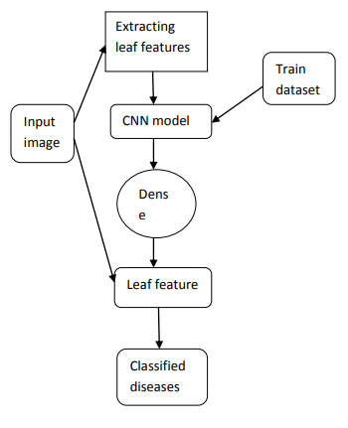

**Figure 1. Use Case diagram**

## Class Diagram :-

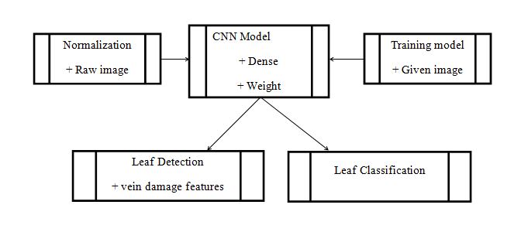

**Figure 2. Class diagram**

## Collaboration Diagram :-

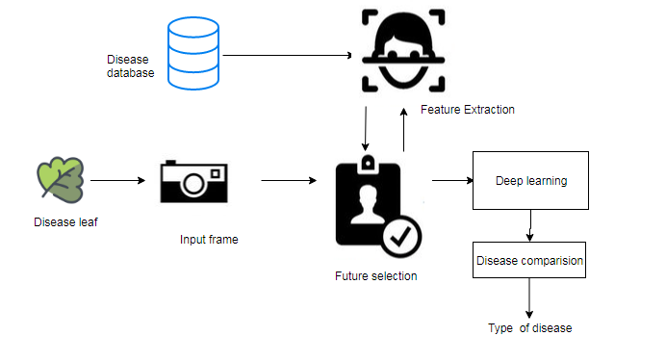

**Figure 3. Collaboration diagram**

## Activity Diagram :-

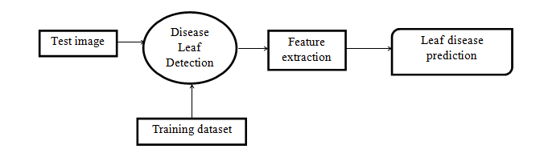

**Figure 4. Activity diagram**

## State Diagram :-

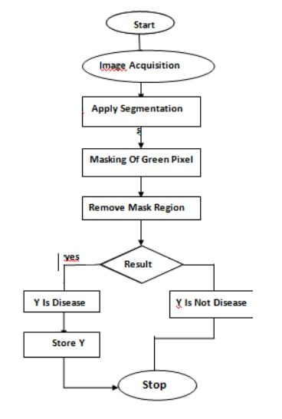

**Figure 5. State diagram**

# SYSTEM REQUIREMENTS

In our system we are using different software and hardware requirements.

## Hardware requirements :-

## 

## Processsor :- i3 (Processsor)

## Ram:- 8GB Ram

## O.S:- Windows

## Hard disk 30GB

## Software requirements :

## OPERATING SYSTEM: WINDOWS

## ANDROID STUDIO

## JDK,SDK

## SQLITE3

## SPYDER IDE

## PROGRAMMING LANGUAGES:JAVA,PYTHON

# IMPLEMENTATION

## SNAPS :-

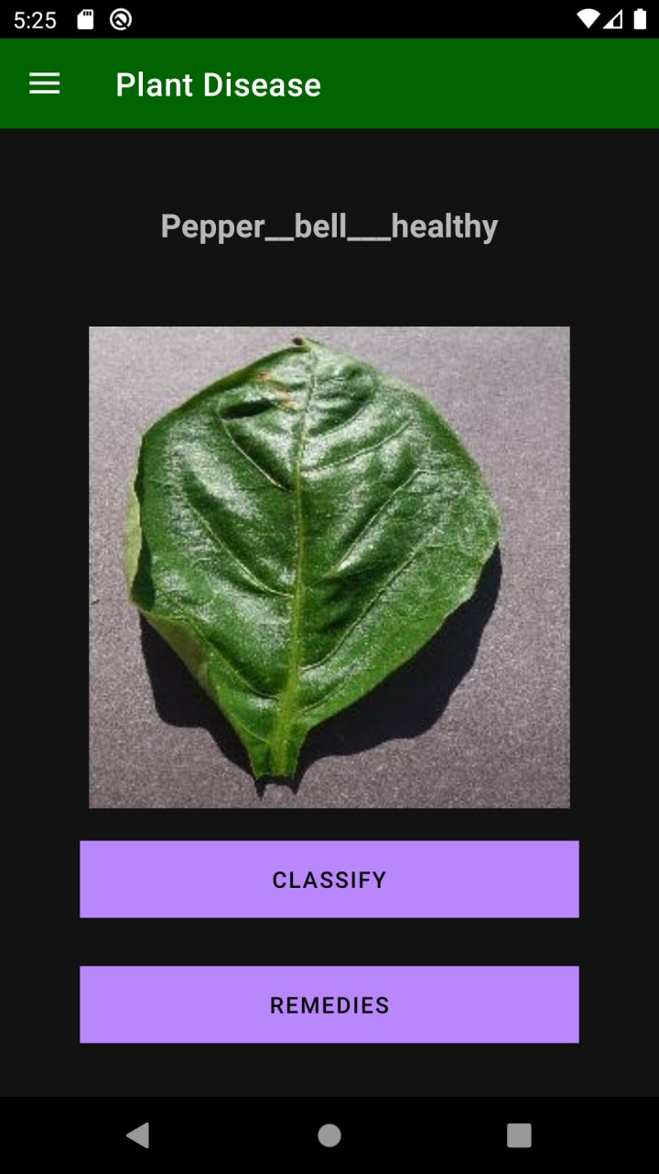

**Figure 6. Home page**

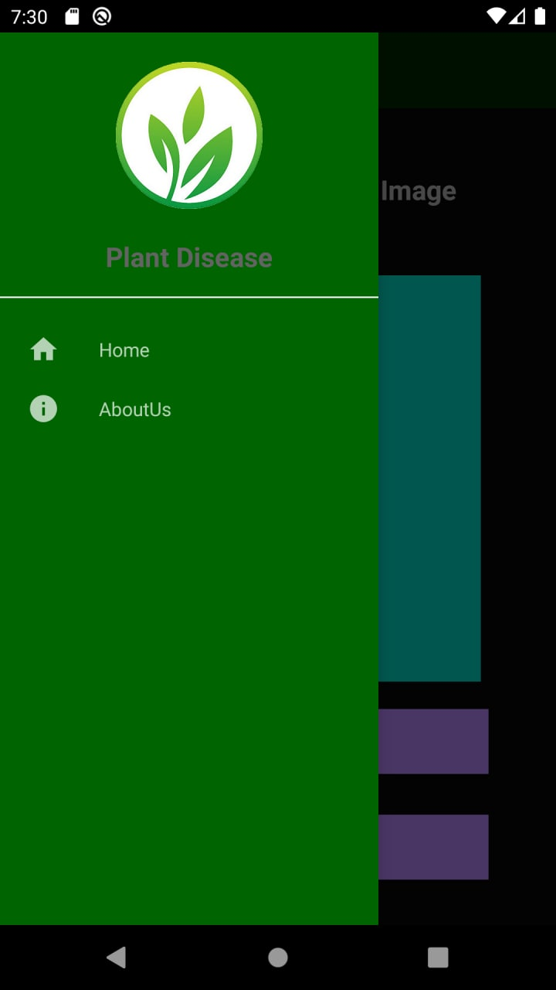

**Fig : App-module**

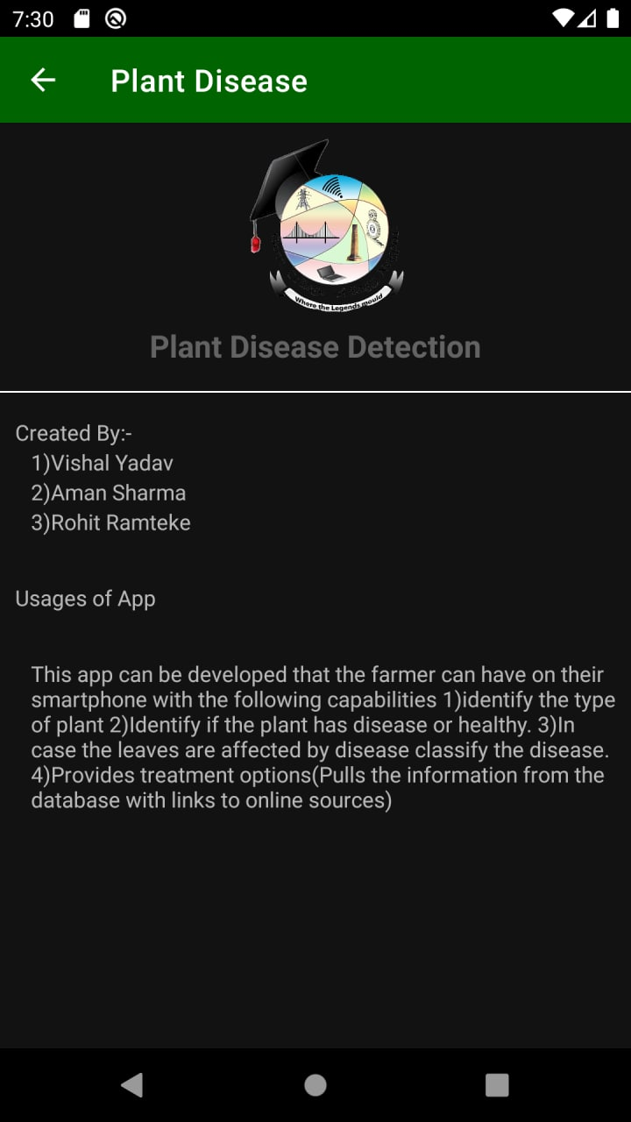

**Fig: App-about Discription**

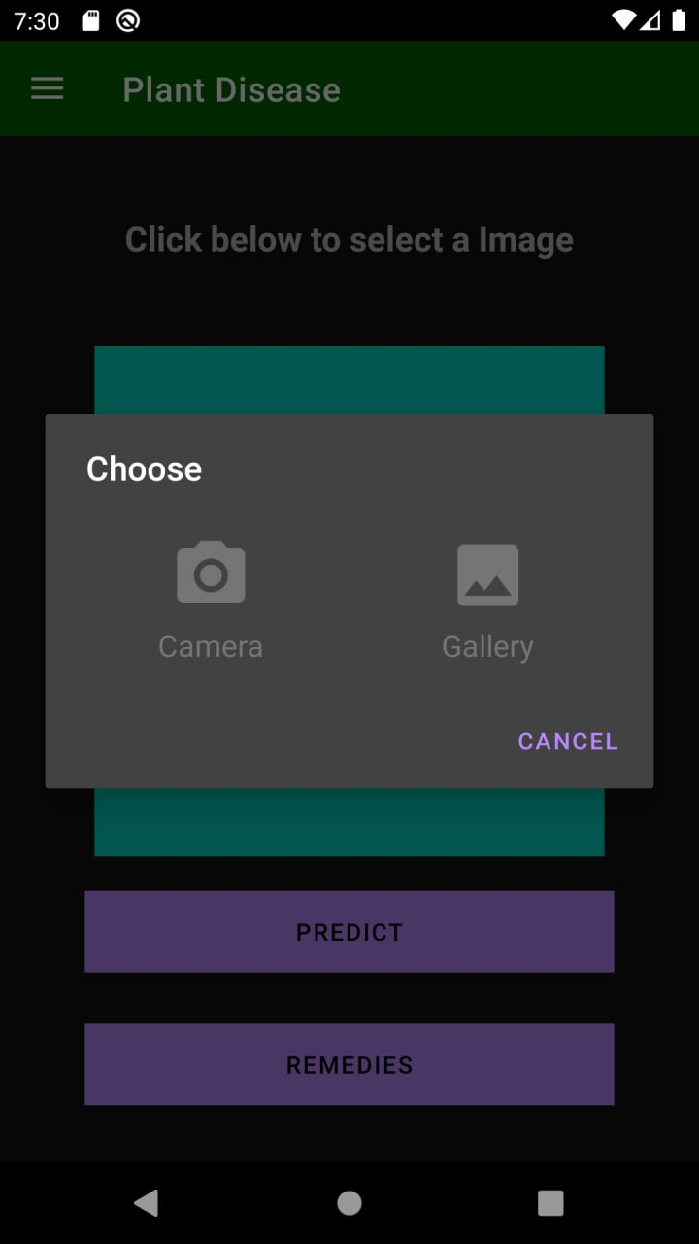

**Fig: Selecting image in app**

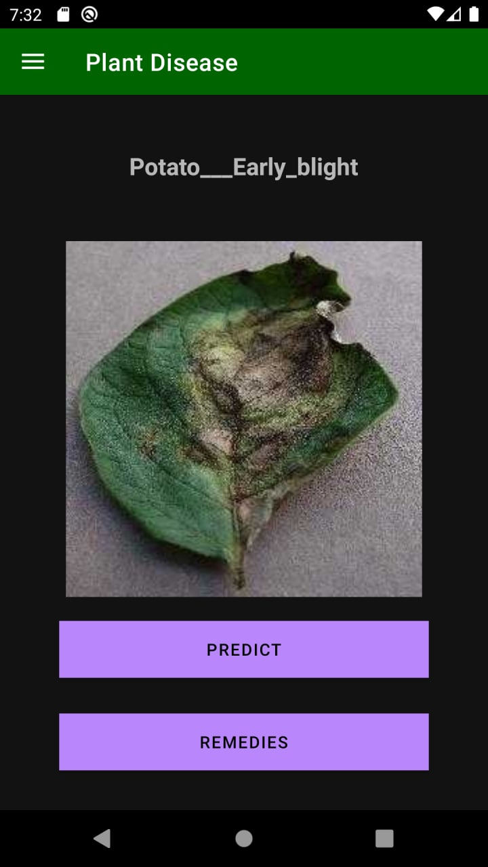

**Fig: Selected Image**

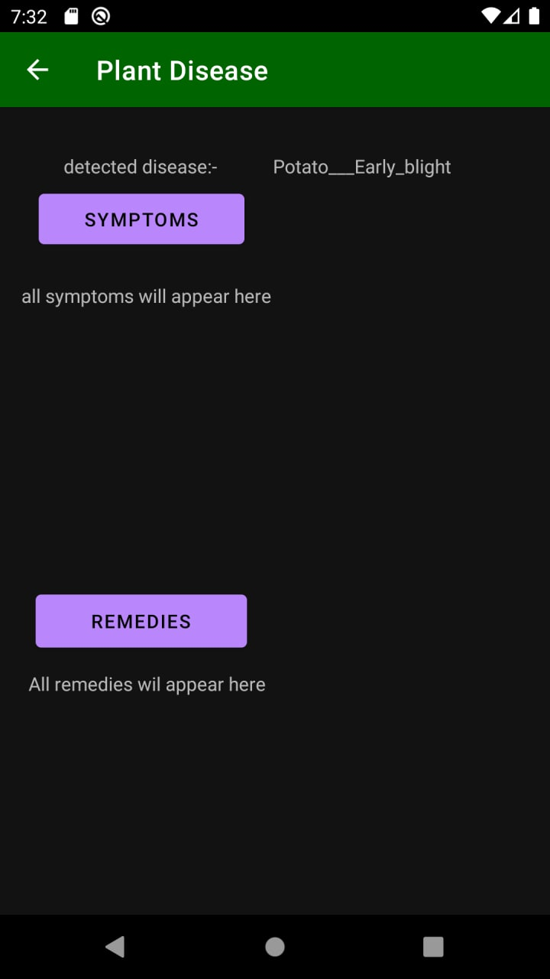

**Fig: Result after image processing**

## WORKING :-

## 6.2.1. THE AI MODEL

## We used convolution networks for image classification of the disease classes. We converted the model and optimized it using the tensorflowlite format to be used on the android application in memory and time-efficient manner. The tensorflowlite converts the large heavy deep learning models to a smaller and mobile hardware supportive format. It also quantizes the parametric learning weights to reduce the model file size. For example, we converted our convolution model file of 2mb to 200kbs without compromising on the performance of the model. All the database for this app is stored locally to avoid the requirement of internet connection for its usage. The user just needs to click the image of his plant and the app helps them out with the rest.

**6.2.2. THE ANDROID APPLICATION**

The android application was developed using the android studio framework. The different phases of the application involve a live camera feed in the beginning. The user clicks an image from the camera feed. The application sends this image for preprocessing from where it is pushed as input to the AI model (The Magic Box). The AI model outputs the class of the plant and disease. We use this to pull out information about this plant and disease from our knowledge base. The application then displays all the relevant information about the prediction for the farmer's help.

# SOFTWARE TESTING

## VALIDATION AND CHECKS:-

Software validation is achieved through a series of tests that demonstrate conformity with requirements. Validation succeeded when software functions in a manner that can be reasonably expected by the customer here line by line checking is used to find error comment line facility is used for checking errors.

Testing is necessary for the success of the system. During testing program to be tested is executed with a set of test data and the output of the program for test data is evaluated to determine if the programs are performing as expected.

Validation means checking the quality of software in both simulated and live environments. System validation ensures that the user can in fact match his/ her claims specially system performance. True validation is verified by having each system tested.

First the application goes through a phase often referred as alpha testing in which the errors and failures based on simulated user requirements are verified and studied. The modified software is then subjected to phase two called beta testing in the actual user's site or live environment. After a scheduled time, failures and errors are documented for final correction and enhancements are made before the package is released.

## TESTING OBJECTIVES ARE:-

Testing process of executing a program with the intent of finding an error. A good test case is one that hash a high probability of finding an undiscovered error. Successful test is one that covers is yet undiscovered error class testing is performed at four different level.

## UNIT TESTING:-

In unit testing, different modules are tested against the specifications produced during the design phase for the modules in the project and the goal is to test the internal logic of the modules.

In order to perform the unit testing, the best approach we adopted in this project is functional testing in which inputs are given to the system for which the expected results are known, boundary values and special values. For this the module selected was advanced details where the balance amount falls to negative indication there is no more payment required. Secondly performance testing was done to determine the amount of execution time spent in various aspects like the module, program throughput, response time, and the device utilization by the program unit.

## INTEGRATION TESTING

The primary goal of the integration testing is to see if the modules can be integrated properly. The integration testing is therefore considered as testing the design. Thus in the integration testing step, all the errors uncovered are corrected for the next testing steps.

## SYSTEM TESTING:-

System testing is similar to integration testing, but instead of integrating modules into programs for testing, programs are integrated into systems for testing the interfaces between programs in a system. System testing can be defined in many ways, but a simple definition is that validation succeeds when the software functions in a manner that can be reasonably expected by the customer.

# RESULT

* Majority of farmer will be benefitted by this app.
* People who work with plants will also be benefitted
* In future will will be expanding our project so that it should be able to predict diseases in more that three plants .
* Integrating climate data for crop yield prediction and recommendations.
* Chatbot for personalised help.
* Ordering fertilizer from ecommerce site.
* Setting reminder for pesticides/watering etc
* Advising on best practices.

# APPLICATION

* Timely and correct identification of disease when it first appears is a critical step for efficient disease management.
* An app can be developed that the farmer can have on their smartphone with the following capabilities

1)identify the type of plant

2)Identify if the plant has disease or healthy.

3)In case the leaves are affected by disease classify the disease.

4)Provides treatment options(Pulls the information from the database with links to online sources)

# CONCLUSION

It focused how image from given dataset (trained dataset) in field and past data set used predict the pattern of plant diseases using CNN model. This brings some of the following insights about plant leaf disease prediction. As maximum types of plant leaves will be covered under this system, farmer may get to know about the leaf which may never have been cultivated and lists out all possible plant leaves, it helps the farmer in decision making of which crop to cultivate. Also, this system takes into consideration the past production of data which will help the farmer get insight into the demand and the cost of various plants in market.

# REFERENCES

[1] Aakanksha Rastogi, Ritika Arora, Shanu Sharma, “Leaf Disease Detection and Grading using Computer Vision Technology &Fuzzy Logic,” presented at the 2nd International Conference on Signal Processing and Integrated Networks (SPIN), IEEE, 2015, pp. 500–505.

[2] Garima Tripathi, Jagruti Save, “AN IMAGE PROCESSING AND NEURAL NETWORK BASED APPROACH FOR DETECTION AND CLASSIFICATION OF PLANT LEAF DISEASES,” Int. J.Comput. Eng. Technol. IJCET, vol. 6, no. 4, pp. 14–20, Apr. 2016.

* [www.google.com](http://www.google.com/)
* [www.wikepedia.com](http://www.wikepedia.com)
* <https://www.kaggle.com/emmarex/plantdisease>

Plant Disease Detection using Ai Techniques (IJSRD/Vol. 7/Issue 12/2020/27)

# APPENDICES

* PYTHON 3.6 OR >
* KERAS
* SCIKIT-LEARN
* MATPLOTLIB
* OPENCV
* SQLITE3